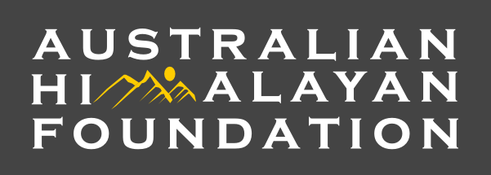

TEN AUSSIE SUMMITS CHALLENGE AND FUNDRAISER
INFORMATION SHEET

Introduction
The Australian Himalayan Foundation in conjunction with K7 Adventures invites you to participate in the Top Ten Aussie Summits Challenge and Fundraiser from 16-19 November 2019 in Australia’s high country. The challenge is to climb the ten highest peaks in Australia over a four-day period with some of Australia’s most experienced Mountain Guides. Set yourself a challenge and raise funds for the Australian Himalayan Foundation.

Location and Peaks
The top ten peaks in Australia are located in the southern end of the Kosciuszko National Park, NSW. Most can be accessed from our base at Thredbo Village with the remaining peaks from nearby Charlotte’s Pass. The top ten peaks are:

1. Mt Kosciuszko, 2228 m 2. Mt Townsend, 2209 m
3. Mt Twynam, 2195 m 4. Rams Head, 2190 m
5. Etheridge Ridge Peak, 2180 m 6. Rams Head North, 2177 m
7. Alice Rawson, 2160 m 8. Abbot Peak, 2159 m
9. Abbot Peak East, 2145 m 10. Carruthers Peak, 2145 m

Program
The trek is 70 km in length with 25 hours of walking (not including breaks) to reach all summits. The four-day lodge-based program will allow time to enjoy the wonderful alpine scenery (without feeling you need to rush off to the next summit). The ten summits challenge is a great way to get fit, explore the magnificent Kosciuszko National Park, prepare you for a longer trek in Nepal or elsewhere, and raise funds for a worthy cause.

There is a three-day option available for the time challenged that enables you to climb eight summits, or the two-day option where you can achieve six summits.

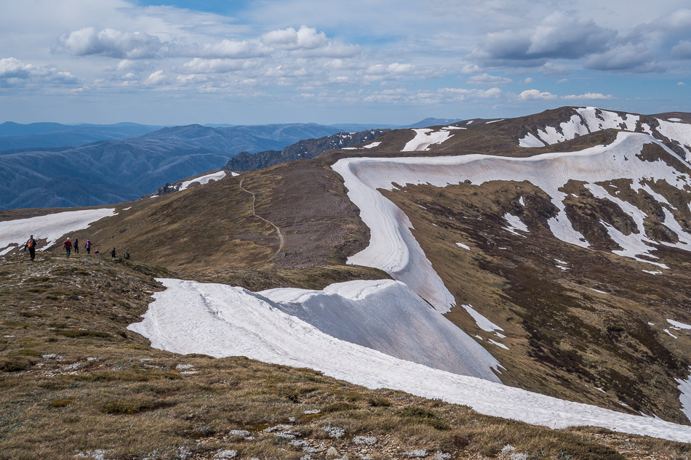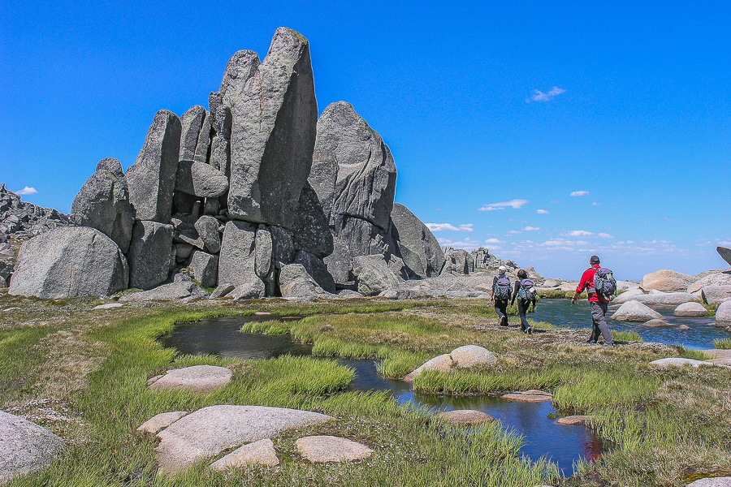

Heading towards Mt Caruthers. Mike Edmondson Granite tors near Rams Head North Mike Edmondson
Accommodation, Meals and Evening Program
Accommodation is at the Kiama Lodge. Centrally located in Thredbo Village, it provides good quality lodge-style accommodation and all meals. We are close to restaurants, the golf course and chairlift. Thredbo Village has a wonderful charm and is a lovely place to relax after a hard day’s walk. Our evening program includes audio-visual presentations from your experienced Alpine Guides. Mike Edmondson is a renowned mountain photographer and cross-country ski instructor with K7 Ski School. Mike’s award-winning mountain photographs are showcased in a gallery in Jindabyne. Zac Zaharias, CSM is one of Australia’s most experienced and successful high-altitude mountaineers, K7 Adventures Nordic ski instructor and AHF’s Canberra coordinator. Zac is a three-time Everest climber and will provide a fascinating presentation on climbing Mt Everest. Our third presenter will be AHF Ambassador Andrew Lock, OAM who will give you an overview of the AHF’s programs. The final night will be a celebration dinner in one of the fabulous local restaurants.

Fundraising/Sponsorship
The combined height of all ten peaks is 21,788 metres (although you won’t actually ascend that height). There are a number of options for seeking sponsorship from friends such ascents per metres ($217.88) or perhaps even a set amount per peak, say $1-$100 per peak. All donations to the AHF above $2 are tax-deductible. However, as a minimum goal we ask that you raise $ 500.

Tour Cost
The cost per person is as follows:
- 3 day / 2 night option 16-17 Nov $ 500
- 3 day / 3 night option 16-18 Nov $ 750
- 4 day / 4 night option 16-19 Nov $ 1,000

Inclusions
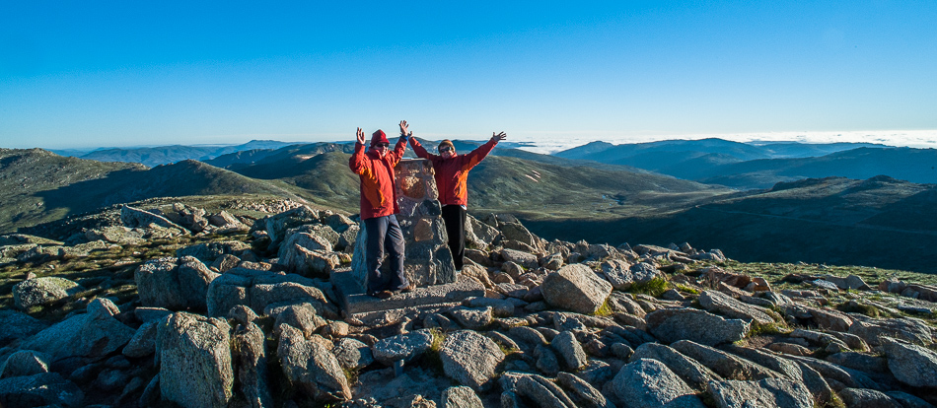
- Accommodation (bunk room style with communal bathrooms – double beds available)
- All meals
- Ski Lift passes
- Guiding services

Not included:
- Travel to and from Thredbo
- Alcoholic drinks, eating out.
- Personal clothing and equipment The summit of Mt Kosciuszko. Mike Edmondson

Bookings
Please complete the booking form and email to ahf@k7adventures.com or mail to PO Box 136, Thredbo Village 2625. On payment, you will receive an information sheet covering all clothing, equipment and training requirements to help you prepare for your adventure.

Contact
If you have any further questions, feel free to contact your guides:
- Zac Zaharias, 0402-286 257, info@peaklearning.com.au
- Mike Edmondson, 0410-903539, mike@mikeedmondson.com.au or
- Acacia Rose, Manager K7 Adventures 0402-298821 ahf@k7adventures.com

