“Ed Hillary’s backyard” tour of NZ with Peter Hillary.

Rescheduled to March/April 2022* (*exact dates and itinerary to be confirmed, and subject to COVID travel restrictions).

Peter Hillary shows you the Hillary family’s “best of the best” of NZ.

An amazing experience, supporting the vital projects of the Australian Himalayan Foundation – carrying on Ed Hillary’s education and health legacy.

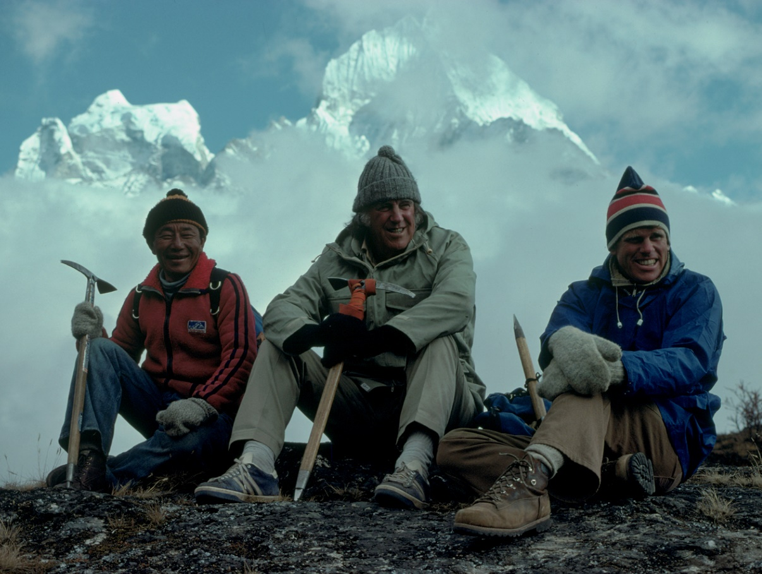
Mingma Tsering, Ed Hillary and Peter Hillary near Khunde.

This trip, personally devised and led by Sir Edmund Hillary’s son Peter, will feature:
- the Hillary family’s favourite places and see the mountainous regions (including Ed’s “first decent mountain”) that inspired Sir Edmund Hillary, and Peter to take on the great peaks of the world.
- The homes, heritage, family and friends, of Sir Edmund and the Hillary family
- a stunning array of natural and cultural sites of NZ, including conservation projects; national parks, high country sheep stations; trail walks and a mountain gondola trip;
- Excellent accommodation
- Wineries and optional activities such as other special mountain flights and fly fishing
- Maximum of 10 people in group.

A truly outstanding 15-day journey, it will be full of wonderful experiences, including personal family insights and memories shared by Peter and other family members and friends of Ed integral to his humanitarian work and legacy in the Himalaya and the Australian Himalayan Foundation’s vital work inspired by and carrying on that legacy. Ed’s work, along with a love of the people of the Himalaya shared with him, was the inspiration behind the formation and work of the Australian Himalayan Foundation.

Peter Hillary, two-time Everest summiteer, adventurer and trip guide, is a Founding Director of the Australian Himalayan Foundation and will be joined on this trip by AHF Chairman Simon Balderstone AM, also an experienced trip leader and guide.

Cost: A$ 6,950 (with a single room upgrade of A$1850), plus a A$5000 donation (tax-deductible) to the Australian Himalayan Foundation. The trip cost includes all hotels (twin-share) and breakfasts; transport in NZ; welcome and end-of-trip dinners. It excludes international airfares and lunches and dinners unless specified.

Group limited to maximum of 10 people.

Dates; This trip is now planned for March/April 2022 - exact dates and itinerary to be confirmed, and subject to any changes to COVID travel restrictions.

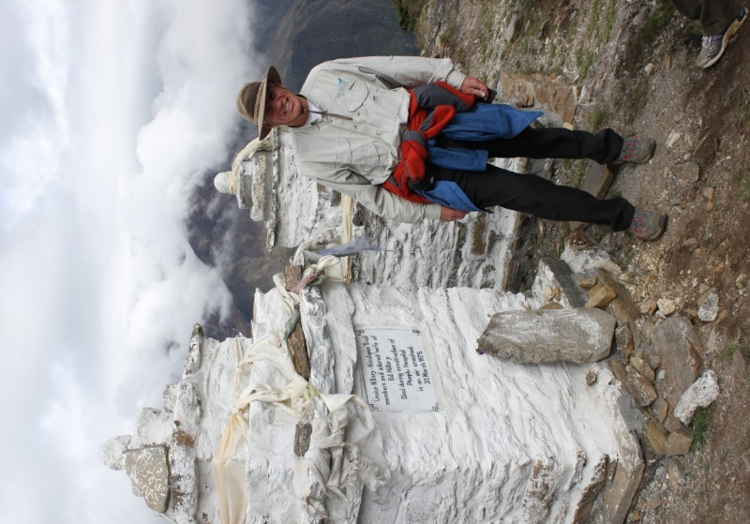
Peter Hillary at shrine honouring his father. Above Khunde.

Program and itinerary

This tour of New Zealand takes you to some of the most spectacular parts of the country as we visit national parks from Fiordland in the south to Tongariro in the north. We will also visit some of New Zealand’s most successful small conservation parks including where degraded farmland is returned to native forest and indigenous birds at Hinewai near Akaroa run by a man with strong family connections to the Hillary family. We will also have a farmers tea at a high country homestead in the Southern Alps in the marvellous Matukituki Valley beneath Mt Aspiring, visit Peter Hillary’s house on the flanks of One Tree Hill in Auckland and visit the ‘wild side of Auckland’s isthmus’ where the Tasman Sea pounds the coast, with the prevailing westerly at its back, and a site where Sir Edmund Hillary dreamed up his expeditions to the Himalayas and Antarctica and which the Hillary’s continue to use as their family retreat. This journey through New Zealand is an eclectic mixture of sensations and experiences from the heart-and-soul of the country’s most famous son, Sir Edmund Hillary, and brought to you by his son, Peter.

New Zealand is the jewel of the southern South Pacific. With a temperate climate and stunning landscapes and peopled by a small population of ‘can-do’ types who love adventure; New Zealanders enjoy one of the best lifestyles on the planet.

Activities: Peter Hillary will guide the group through New Zealand on this itinerary and provide personal insights into the land and people we visit. Each evening at around 5 to 6pm there will be group briefing meetings and short presentations. Parks and conservation is a central theme to this journey through NZ as well as an insight into what created the legendary first man to climb Mt Everest and whose generosity of spirit saw him spend 50 years of his life building schools and hospitals for the mountain people of Nepal around the foot of Mt Everest.

Provisional itinerary:
Day 1: Arrive Queenstown in the middle of Otago in southern NZ, a province filled with adventure and where the Hillary family has always come ‘to head for the hills!’ Transfer 20 mins to hotel; welcome reception at Novotel Queenstown Lakeside Hotel.

Day 2: Drive to Fiordland National Park via Te Anau and Milford Sound (4 hours). 2 hr. Milford Sound nature cruise. Return to Queenstown. Dinner at Novotel Queenstown Lakeside Hotel or in the town.

Contingency plan due to weather: Aim to swap with day 3 if we see unfavourable weather conditions for day 2.

Day 3: Drive from Queenstown over the Crown Range to Wanaka (1 hr) for a brief stop and walk on the shore of Lake Wanaka. Drive up the Matukituki Valley to Mt Aspiring National Park. Visit the high-country sheep station near the end of road for tea. The Aspinall family are friends of the Hillary’s and have run the farm for nearly one hundred years. Continue to the road end and go for a short walk up valley. Picnic lunch. Return to Queenstown. Dinner at Amisfield Winery Lake Hayes with a short talk by the director of the Kea Conservation Trust that works on conservation of the world’s only alpine parrot, the Kea.

Day 4: Drive from Queenstown to Mt Cook via the Lindis Pass (2.5-3 hrs.; depart 8am, arr 11am latest). Weather permitting: Mt Cook Ski plane flight up the Tasman Glacier and land on the upper glacier and then fly back past Mt Cook to the Mt Cook airport (60 mins) (flight is extra cost). Lunch at Old Mountaineer Cafe. Walk up the trail into the Hooker Valley towards the glacial lake. Visit Sir Edmund Hillary Alpine Centre. Dinner at the Hermitage with a talk by Peter Hillary about mountaineering in the Mt Cook region. Stay at the Hermitage Mt Cook.

Contingency plan due to weather: flights could be at any time during the day or early on the Day 5.

Day 5: Drive from Mt Cook to Akaroa for late lunch at local restaurant (5.5 hrs.) or stop for lunch en route to Akaroa depending on time. Visit Hinewai which is a new park above the town where degraded farmland is being returned to native forest. Meet the park’s manager and visionary Hugh Wilson. (The Wilson family are old Hillary family friends.) Dinner at leisure. Akaroa Village Inn.

Day 6: Akaroa Voyage on Akaroa Harbour looking for rare Hectors Dolphin and sea birds (90 mins). Free afternoon in Akaroa. Akaroa Village Inn.

Day 7: Drive from Akaroa to Kaikoura via Christchurch (4 hrs.). Go for a Whale Watch voyage on the Pacific Ocean for the evening looking for Sperm whales and albatross (1.5-2 hrs.). Stay at Kaikoura Boutique Hotel on the Esplanade.

Day 8: Scenic drive Kaikoura to Blenheim (2.5 hrs.). Lunch in a local winery (Alan Scott or similar). Guided tour at Omaka Aviation Heritage Museum. Ed Hillary trained for the airforce in Blenheim during World War II and climbed his first ‘decent mountain’ while stationed here; Tapuaenuku. Evening at leisure in Blenheim. Hotel d”Urville for the night.

Day 9: Fly Blenheim to Wellington. Optional walking tour from the Beehive and NZ parliament along to Oriental Bay. Lunch and afternoon free. Speaker about NZ history and development prior to dinner at hotel or local restaurant. Bolton Hotel Wellington.

Day 10: Morning guided tour of Te Papa the national museum and Maori culture experience; afternoon optional "beehive" guided tour; dinner at local restaurant or hotel; guided tour Zealandia by night which is an enclosed biosphere with rare native NZ birds and animals on the fringe of Wellington. Bolton Hotel Wellington.

Day 11: Drive to Mt Ruapehu (5 hrs.) where Ed Hillary first went to the mountains as a schoolboy and realized this is what he wanted to do! Depending on the weather we will take a gondola up part of the mountain to 2100 metres for refreshments at the Knoll Ridge Café; afternoon optional activities including guided short walks (hike towards Mt Ngaruahoe (also known as Mt Doom in the Lord of the Rings Trilogy) across the alpine scrub fields of central volcanic plateau, visit Hillary Outdoors Centre to learn about outdoor programmes for young people. You could even play a game of golf at The Chateau golf course with the volcanic wonderland all around! Dinner at The Chateau. Overnight Chateau Tongariro.

Day 12: Rest day at Mt Ruapehu: Optional activities today include a guided short walk, fly fishing in Turangi and a swim in the Tokaanu hot pools. Chateau Tongariro.

Contingency plan - Gondola excursion possible today if depending on the weather we didn’t take this option the previous day.

Day13: Drive to Auckland (5 hrs.). Drive to Parnell and check in to the Auckland Rose Park Hotel. Lunch en route. Drive along the waterfront and visit the Auckland Art Gallery where Sarah Hillary, Peter’s sister, will address the group about art diversity in New Zealand. We then visit the Auckland Museum (where the Edmund Hillary archive is housed) and drive to Cornwall Park and One Tree Hill for views out over the Auckland isthmus and the city. Then walk down to the base of One Tree Hill and enter from the park into Peter Hillary’s personal residence for an evening aperitif. Group briefing about the city of Auckland and its history. Dinner is at leisure. Auckland Rose Park Hotel in Parnell.

Day 14: Leave the hotel at about 0900 for a visit to the West Coast of Auckland and a visit to the ‘Hillary Bach,’ or cabin, perched at the top of a cliff 100 metres high and looking out on to the Tasman Sea. There will be time to walk down to stroll on spectacular White’s Beach before a light lunch and return to Auckland. (Less than one hour drive.) Farewell dinner at our hotel. Auckland Rose Park Hotel in Parnell.

Day 15: Departure home. End of tour.

*Cost Includes:
All hotels and breakfast (hotels as indicated or equivalent due to availability.)
Hire cars and fuel.
Flight from Blenheim to Wellington.
Peter Hillary to accompany and guide the journey “Ed Hillary’s backyard.”
Twin Share hotel rooms. (Single occupancy room is extra)
Welcome and Farewell dinner are included

Not included:
All international flights
Lunches and dinners other than Welcome and Farewell dinner
All drinks, telephone, laundry, phone, etc.
Ski Plane flight, helicopter flights
Wine tasting at vineyards
Golf, fly fishing and other optional activities

