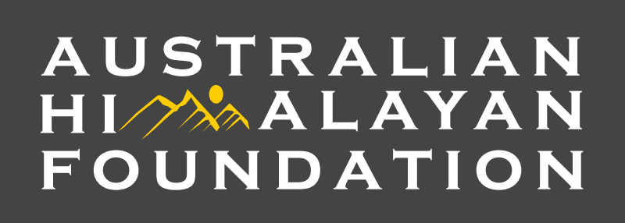

AUSTRALIAN HIMALAYAN FOUNDATION
VOLUNTEER JOB DESCRIPTION

Position title: Volunteer Program Assistant
Reports to: Head of Programs

Organisational background:
AHF was established in 2002 with its mission to improve the quality of life of the people most in need in the remote areas of the Himalaya. Working with local partner NGOs and communities is integral to AHF’s development approach and its aim to help meet their priority needs through integrated improvements in education, health and the environment.

AHF was born from a foundational commitment to ‘giving back’ to the communities that have so generously welcomed Australian and international climbers and tourists to the Himalayan region. We do this in two ways – raising funds to support education, health, environment and integrated community development initiatives, and lending expertise in the form of support and capacity building of our local partners.

Main purpose of the role:
The Volunteer Program Assistant (VPA) works closely with the Head of Programs (HP) and the Programs Manager (PM) and support the program team in the coordination and management of AHF’s international projects, programs and partnerships.

Reporting to the HP, the VPA will support the program team in ensuring AHF’s in-country programs and projects are high-quality and comply with AHF policies and processes, as well as sector-wide compliance standards, including DFAT’s ANCP accreditation requirements, ACFID Code, ACNC and all legal regulations.

The VPA will also support the team in ensuring AHF’s Programs integrate child safeguarding , gender, disability inclusion and environmental considerations into all stages of program management and partnership principles. The VPA will also support the team in ensuring systems, policies and processes that manage and mitigate risks, including fraud, corruption and terrorism are maintained.

KEY ROLES AND RESPONSIBILITIES

- Governance
- Adhere to AHF Policies and Codes of Conduct
- Contribute to ensuring projects and partnerships meet DFAT base accreditation and help HP develop AHF processes to meet DFAT full accreditation requirements
- Contribute to maintaining standards in accordance with the ACFID Code of Conduct and other best practice guidelines

- Program and Partnerships Management

- Support the HP in the implementation of the ‘Integrating People, Wildlife and Climate change in Zanskar, Ladakh’ implemented with Snow Leopard Conservancy India Trust
- Support the PM in the implementation of the ‘Everest Youth Climate Initiative, Nepal’ implemented with REED.
- Contribute to ensure all projects and programs are implemented in line with AHF policies and ensure in-country partners are compliant.
- Contribute to ensuring implementation of a high-performance monitoring and evaluation framework of all projects and programs, in particular with regards to the environment.
- Review environmental considerations as they are currently included in the existing programs and provide recommendations for improvement.
- Maintain robust filing systems for all program management and assist in the development of those systems.

- Program and Partnerships Development
- Assist the HP in scoping new environmental opportunity for environmental project in Bhutan.
- Support the preparation of project proposals and reports to relevant donors

- Budget and Financial
- Work with the HP and PM to ensure that project financial information is maintained in accordance with accreditation and legal requirements.

